ALTERNATIVE ARCHITECTURES
CastIron Media — Phase 1 Alternate Approaches
This document presents the two architectures evaluated alongside the recommended Balanced Hybrid approach, priced and diagrammed on the same basis, for when cost, operational simplicity, or raw performance should outweigh the recommendation.

1. Purpose and Relationship to the Recommended Approach
The companion document, CastIron Media Phase 1 Technical Approach, recommends Approach 01 (Balanced Hybrid Lakehouse) and covers it in full — requirements, architecture, performance, the clean-room design, delivery, and cost. This document covers the two architectures that were evaluated against it and set aside: Approach 02 (Cost-Optimized Classic Micro-Batch) and Approach 03 (Fully Serverless, Performance-Optimized). All three share the same Phase 1 requirements, the same clean-room pattern, and the same cost methodology — only the compute strategy for streaming, identity resolution, and SQL serving differs between them.
Key notes
Clean room: identical across all three approaches — CastIron's own Snowflake provider account, same AWS region as the partner, read-only Iceberg offering linked into the partner's Collaboration Data Clean Room. See the Technical Approach document, Section 6, for the full design; it is not repeated per approach here beyond the summary table in each section below.
Costs: approximate list prices (AWS us-east-1, Databricks Premium tier) for planning only, same basis as the Technical Approach document's Section 9 assumptions.

2. Approach 02: Cost-Optimized Classic Micro-Batch
All compute runs on classic clusters in the customer VPC without Photon, using spot workers and scheduled micro-batches instead of continuous streaming. Events are ingested from Firehose's S3 delivery, and the identity graph stays hosted by the licensor.
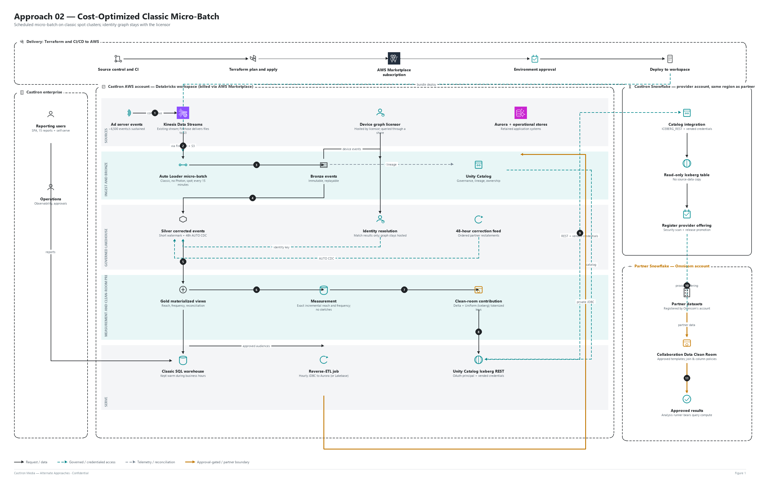
Figure 1. Approach 02 architecture — scheduled micro-batch, hosted identity

2.1 How this approach delivers Phase 1
Phase 1 requirement | How this approach delivers it
Streaming ingest | Existing Firehose delivers files to S3; Auto Loader processes them every 15 minutes with Structured Streaming jobs (bronze, silver, gold). Same stored-procedure decomposition and shadow/parity process as the recommended approach; quality checks built in code.
Identity resolution | Graph remains with the licensor and is queried through a share; only match results are stored.
Measurement | Exact incremental reach and frequency from the household-day aggregate; no sketches.
Clean room | Same pattern as the recommended approach: a CastIron-owned, same-region Snowflake provider account links a read-only Iceberg offering into Omnicom's Collaboration Data Clean Room — no row-level reads from the partner's account.
Reverse-ETL | Hourly Spark JDBC upserts into Aurora MySQL.
Reporting and orchestration | Classic SQL warehouse, kept warm during business hours; Lakeflow Jobs orchestration.

2.2 How it performs
Metric | Expected performance
Event to silver latency | 15 to 30 minutes (Firehose buffer + 15-minute schedule)
Event to report marts (gold) | 30 to 45 minutes
Burst handling | Backlog builds if a batch exceeds its interval; manual resizing
Identity daily match | ~1 to 2 hours; depends on the licensor's data layout and region
30-day reach and frequency refresh | ~2 to 3 hours daily
SPA packaged reports | p95 3 to 8 s; 4 to 6 minute cold start if the warehouse is stopped
Self-serve builder | Several seconds on large slices
Reverse-ETL freshness | Hourly
Recovery | Re-run failed batch; more manual tuning

2.3 Approximate monthly cost by resource and workload
Workload | Resource and sizing | Usage basis | Databricks (USD/mo) | AWS (USD/mo) | Total (USD/mo)
Event ingest | Existing Firehose with S3 delivery (billed per 5 KB record increment) | 24x7 | - | 370 to 2,450 | 370 to 2,450
Streaming micro-batch | Jobs compute, no Photon; driver + 4 x r6gd.2xlarge (spot), instance pool | ~12 effective h/day | 550 | 530 | 1,080
Late data and 48 h restatement | Jobs compute; driver + 4 x r6gd.xlarge (spot) | ~2 h/day | 50 | 40 | 90
Identity resolution (hosted) | Jobs compute, no Photon; driver + 8 x r6gd.2xlarge (spot) | ~1.5 h/day | 120 | 80 | 200
Measurement | Jobs compute, no Photon; driver + 4 x r6gd.2xlarge (spot) | ~5 h/day | 230 | 180 | 410
Clean-room contribution | Jobs compute; driver + 2 x r6gd.xlarge; partner read requests | ~1 h/day | 15 | 35 | 50
Reverse-ETL | Jobs compute from instance pool | Hourly, ~5 min/run | 30 | 30 | 60
SPA reporting | Classic SQL warehouse, Small (12 DBU/h) + EC2 in own account | Kept warm ~16 h/day | 1,270 | 1,500 | 2,770
Lakehouse storage | S3 Standard (no resident graph) | ~23 TB avg + requests | - | 610 | 610
Network and security | NAT (2 AZ), VPC endpoints, KMS, CloudWatch | 24x7 | - | 300 | 300
Non-production | Dev + staging (~15% of production compute) | Auto-terminate | 500 | 200 | 700
Total (steady state) |  |  | 2,765 | 3,875 to 5,955 | ~6,640 to 8,720
Annual run cost: approximately USD 80,000 to 105,000. The Firehose range depends on whether events are aggregated into larger records (Firehose rounds each record up to 5 KB). Firehose is already part of today's bill. Licensor hosting fees for the identity graph are not included, and this excludes the separately billed Snowflake clean-room account (~USD 6,000 to 14,400/year, see the Technical Approach document Section 6).

2.4 Drawbacks
- Data latency of 30 to 45 minutes; not suitable for near-real-time reporting.
- Most engineering and operations effort of the three approaches: custom quality, recovery and tuning; more incidents to manage.
- Retains the Firehose dependency; Firehose cost can reach ~USD 2,450/month after Redshift retirement if records are not aggregated.
- Hosted identity limits join optimization compared with a resident graph.
- Classic SQL warehouse cold starts and slower interactive performance for the SPA.

3. Approach 03: Fully Serverless, Performance-Optimized
All workloads run on Databricks serverless compute: continuous serverless pipelines, serverless jobs and a larger serverless SQL warehouse. There are no clusters to size or patch, and capacity scales automatically.
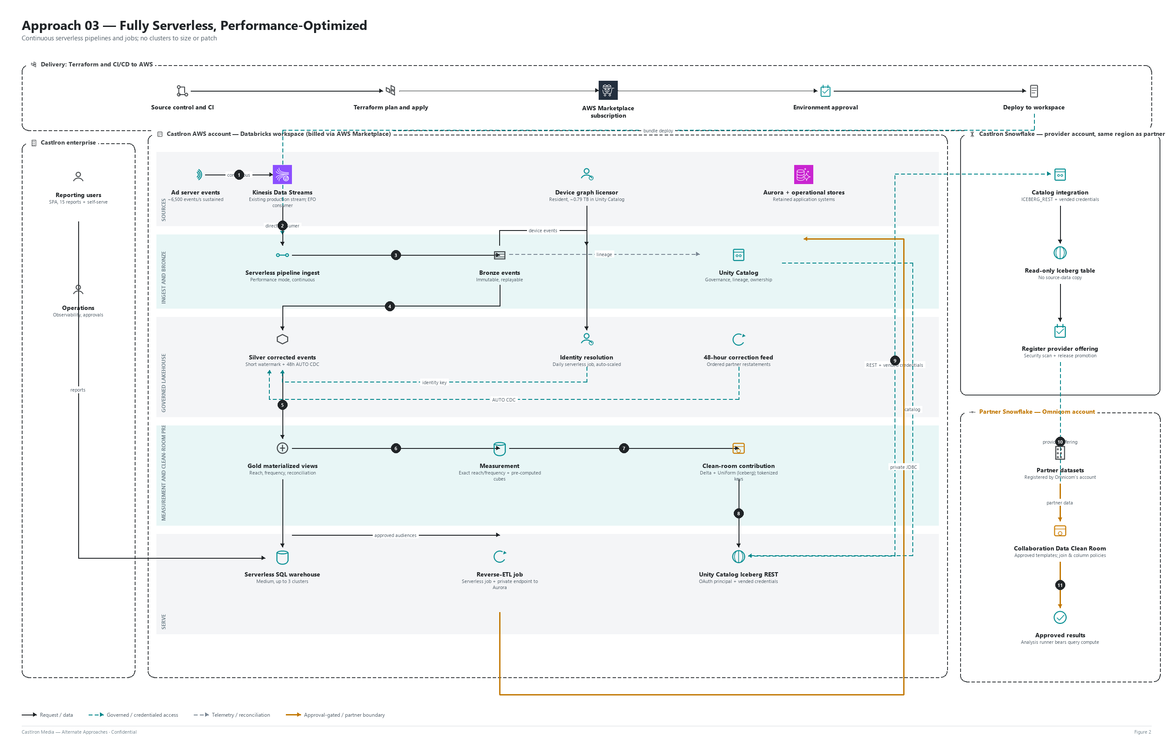
Figure 2. Approach 03 architecture — continuous serverless, resident identity

3.1 How this approach delivers Phase 1
Phase 1 requirement | How this approach delivers it
Streaming ingest | Kinesis EFO consumer into serverless declarative pipelines in performance mode (continuous). Same stored-procedure decomposition and shadow/parity process as the recommended approach.
Identity resolution | Resident licensed graph; daily serverless job with automatic scaling.
Measurement | Exact reach and frequency plus pre-computed cubes for the most-used report dimensions.
Clean room | Same pattern as the recommended approach: a CastIron-owned, same-region Snowflake provider account links a read-only Iceberg offering into Omnicom's Collaboration Data Clean Room — no row-level reads from the partner's account.
Reverse-ETL | Serverless jobs writing to Aurora through a private endpoint (network connectivity configuration).
Reporting and orchestration | Serverless SQL warehouse, Medium, up to 3 clusters for high concurrency; Lakeflow Jobs orchestration.

3.2 How it performs
Metric | Expected performance
Event to silver latency | Under 1 minute
Event to report marts (gold) | 2 to 5 minutes
Burst handling | Elastic, no capacity planning
Identity daily match | ~15 to 25 minutes
30-day reach and frequency refresh | Under 1 hour
SPA packaged reports | p95 1 to 3 s; instant start; high concurrency
Self-serve builder | Sub-second
Reverse-ETL freshness | 15 minutes to hourly
Recovery | Fully managed retries and restarts

3.3 Approximate monthly cost by resource and workload
Workload | Resource and sizing | Usage basis | Databricks (USD/mo) | AWS (USD/mo) | Total (USD/mo)
Event ingest | Kinesis EFO consumer, 12 shards | 24x7; ~12.6 TB read | - | 300 | 300
Streaming pipeline | Serverless declarative pipelines, performance mode | 24x7 | 5,600 | - | 5,600
Late data and 48 h restatement | Serverless jobs | ~2 h/day | 150 | - | 150
Identity resolution | Serverless jobs; graph on S3 (0.79 TB) | ~25 min/day | 280 | 20 | 300
Measurement | Serverless jobs incl. pre-computed cubes | ~1.5 h/day | 600 | - | 600
Clean-room contribution | Serverless jobs; partner read requests | ~1 h/day | 50 | 20 | 70
Reverse-ETL | Serverless jobs + private endpoint (load balancer) to Aurora | Every 15 to 60 min | 100 | 50 | 150
SPA reporting | Serverless SQL warehouse, Medium (24 DBU/h), up to 3 clusters | ~12 active h/day | 6,050 | - | 6,050
Lakehouse storage | S3 Standard (Delta bronze, silver, gold) | ~23 TB avg + requests | - | 630 | 630
Network and security | Private endpoints, reduced NAT, KMS, CloudWatch | 24x7 | - | 300 | 300
Non-production | Dev + staging (serverless) | On demand | 1,400 | 100 | 1,500
Total (steady state) |  |  | 14,230 | 1,420 | ~15,650
Annual run cost: approximately USD 188,000. Serverless streaming is estimated at about 1.4 to 1.5 times the equivalent classic cost, because serverless rates include the compute infrastructure. This excludes the separately billed Snowflake clean-room account (~USD 6,000 to 14,400/year, see the Technical Approach document Section 6).

3.4 Drawbacks
- Highest run cost of the three approaches: about 1.6 times the recommended approach, driven by continuous serverless streaming and the larger SQL warehouse.
- Premium unit pricing is paid on a steady 24/7 load where classic compute is cheaper.
- Less control over instance types and tuning; EC2 Savings Plans and spot pricing cannot be applied.
- Private access to Aurora and other VPC resources requires additional network connectivity configuration.

4. Comparison with the Recommended Approach
Criterion | Approach 01: Recommended | Approach 02: Cost-Optimized | Approach 03: Fully Serverless
Event to report latency | 5 to 10 min | 30 to 45 min | 2 to 5 min
SPA report performance | p95 2 to 5 s | p95 3 to 8 s, cold starts | p95 1 to 3 s
Monthly run cost | ~USD 9,850 | ~USD 6,640 to 8,720 | ~USD 15,650
Annual run cost | ~USD 118,000 | ~USD 80,000 to 105,000 | ~USD 188,000
Operational effort | Moderate | High | Low
Main drawback | Two compute models to govern | Latency and engineering effort | Highest run cost
Recommendation unchanged
Approach 01 remains recommended (see the Technical Approach document). Its annual run cost (~USD 118,000) is higher than Approach 02's (~USD 80,000 to 105,000) but about 37% lower than Approach 03's (~USD 188,000), while delivering materially better latency and SPA performance than Approach 02. Approach 02 is the right call where a 30 to 45 minute reporting delay is genuinely acceptable and minimizing run cost matters more than engineering effort. Approach 03 is the right call where operational simplicity is worth paying a premium for and the 24/7 serverless rate is acceptable.

